# Experiment No: 7

**Aim:**

Familiarisation of Linux Commands.

# CO2:

Perform System Administration tasks.

# Procedure:

**1)**Expr : To calculate the expression and print the output.

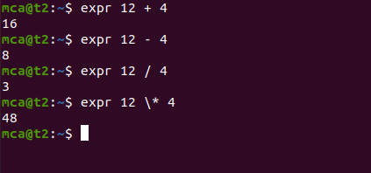

**2)**df - is used to get a report in system space usage ie.how space is taken by the files in the system

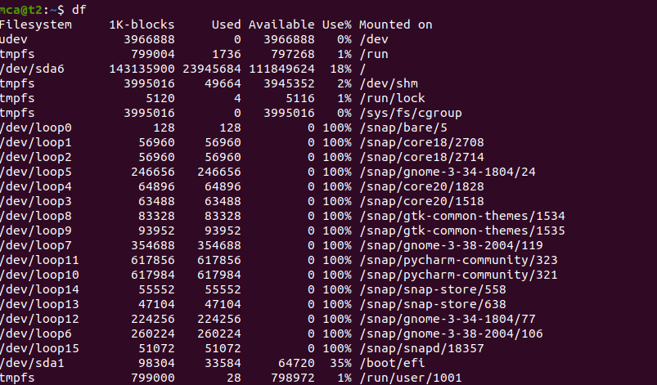

**3)**du- is used to check how much space a file/directory takes in the current directory

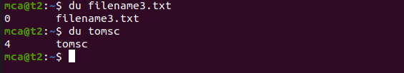

**4)**sudo useradd[username]

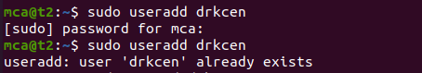

**5)**sudo passwd[username]-To update password

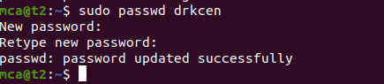

**6)**sudo groupadd -g (group id][groupname]- To create new group

sudo usermod -G[group name][username]

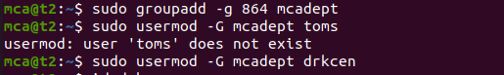

**7)**id [username]-used to find out user id, group id, group

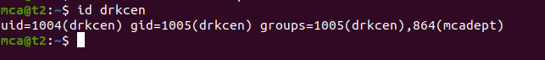

**8)**compgen -g -To Display all groups in the user

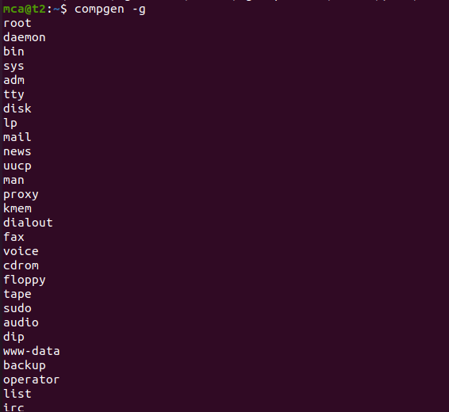

**9)**chmod- it is used to change the access permission of files and directory.Its stands for change mode

read(r),write(w),execute(x)

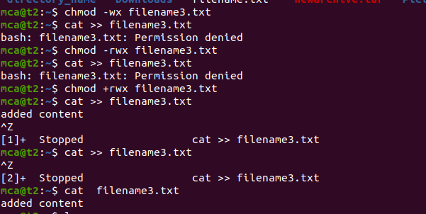

**10)**sudo chown [username][filename] -used to change a file ownership or directory ownership for a user or a group.chown stands for change owner

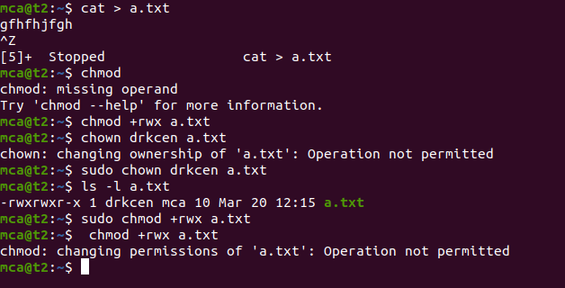

**11)**

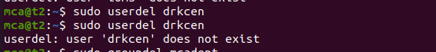

**12)**

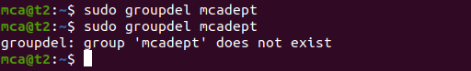

# Result:

The program was executed and the result was successfully obtained. Thus CO2 was obtained.